Pyton hw1

#print "O"

letter_o = ""

for i in range(0, 7):

    for j in range(0, 6):

        if i == 0 and (j>0 and j<5):

            letter_o += "*"

        elif (i>0 and i<6) and (j==0 or j==5):

            letter_o += "*"

        elif i==6 and (j>0 and j<5):

            letter_o += "*"

        else:

            letter_o += " "

    letter_o+="\n"

print(letter_o)

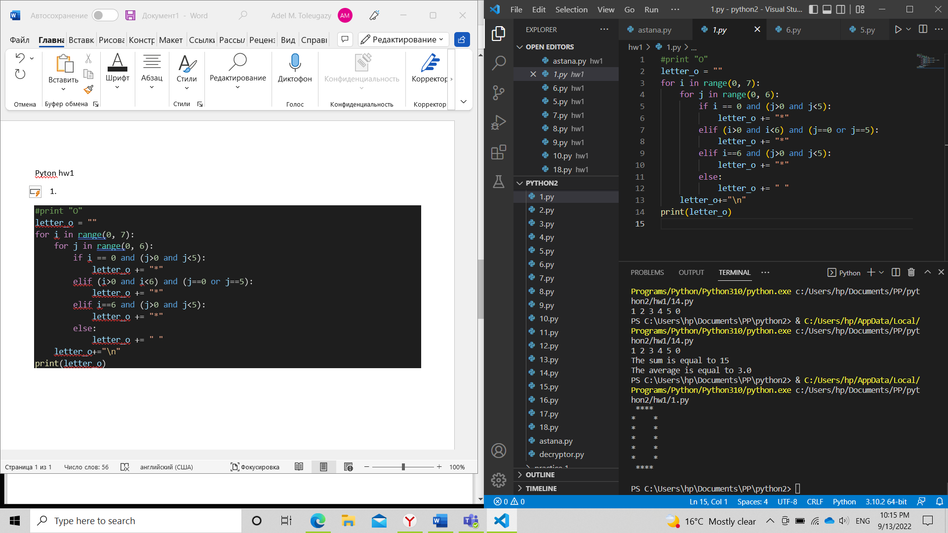

#print "R"

letter_r = ""

for i in range(0, 7):

    for j in range(0, 6):

        if (i == 0 or i == 3) and (j>-1 and j<4) or ((i>0 and i<3) and (j==0 or j==4)) or j == 0 or (i == 4 or i == 5 or i == 6) and (j == i-2):

            letter_r += "*"

        else:

            letter_r += " "

    letter_r+="\n"

print(letter_r)

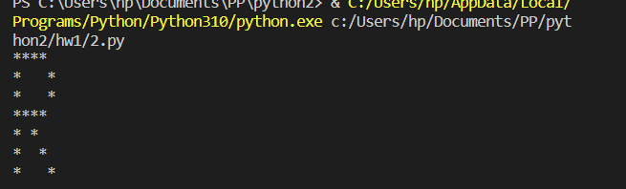

1. Dog’s age

n = int(input())

age = 0

for i in range(n):

    if i == 0 or i == 1:

        age += 10.5

    else:

        age += 4

print("The dog's age in dog's years is", int(age) )

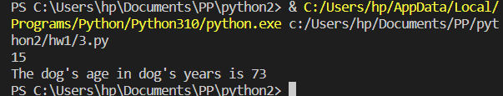

1. Vowel or consonant

letter = str(input())

vowels = "euioa"

answer = False

for i in vowels:

    if letter == i:

        answer = True

if answer == True:

    print(letter, "is a vowel")

else:

    print(letter, "is a consonant")

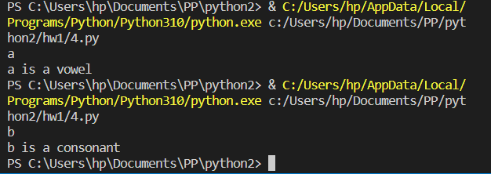

1. Days in month

month = str(input())

days30 = ["April", "June", "September", "November"]

if month == "February":

    print("28/29 days")

elif month in days30:

    print("30 days")

else:

    print("31 days")

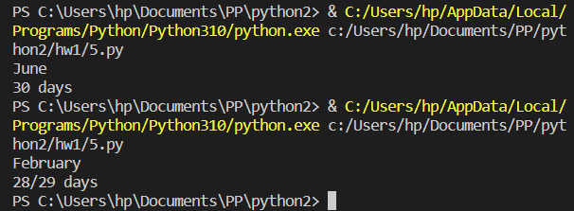

1. sum, but if 15<=sum<=20, return 20

n = int(input())

m = int(input())

sum = n+m

if 15<=sum<=20:

    print(20)

else:

    print(sum)

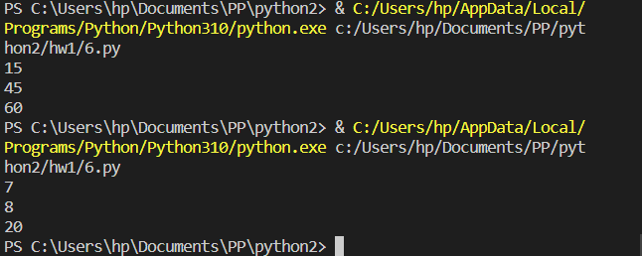

1. integer or not

s = str(input())

if s.isnumeric():

    print("The string is an integer")

else:

    print("The string is not an integer")

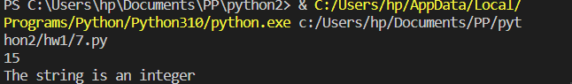

1. triangle

x, y, z = input().split()

if x == y and x == z:

    print("Equilateral triangle")

elif x != y and x!= z:

    print("Scalene triangle")

else:

    print("Isosceles triangle")

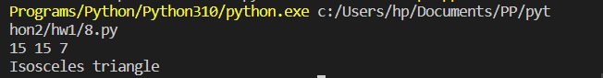

1. seasons

months = {

    "01": "January",

    "02": "February",

    "03" : "March",

    "04" : "April",

    "05" : "May",

    "06" : "june",

    "07" : "July",

    "08" : "August",

    "09" : "September",

    "10" : "October",

    "11" : "November",

    "12" : "December"

}

month = input()

day = int(input())

answer = "winter"

m = months[month]

if month == "03" or month =="04" or month == "05":

    answer = "spring"

    print(f"{m}, {day}. Season is {answer}")

elif month == "06" or month =="07" or month == "08":

    answer = "summer"

    print(f"{m}, {day}. Season is {answer}")

elif month == "09" or month =="10" or month == "11":

    answer = "autumn"

    print(f"{m}, {day}. Season is {answer}")

else:

    print(f"{m}, {day}. Season is {answer}")

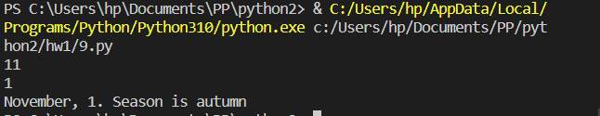

10.

#zodiac signs

day = int(input())

month = str(input())

if month == "January":

    if day < 20:

        zodiac_sign = "Capricorn"

    else:

        zodiac_sign = "Aquarius"

elif month == "February":

    if day < 19:

        zodiac_sign = "Aquarius"

    else:

        zodiac_sign = "Pisces"

elif month == "March":

    if day < 21:

        zodiac_sign = "Pisces"

    else:

        zodiac_sign = "Aries"

elif month == "April":

    if day < 20:

        zodiac_sign = "Aries"

    else:

        zodiac_sign = "Taurus"

elif month == "May":

    if day < 21:

        zodiac_sign = "Taurus"

    else:

        zodiac_sign = "Gemini"

elif month == "June":

    if day < 21:

        zodiac_sign = "Gemini"

    else:

        zodiac_sign = "Cancer"

elif month == "July":

    if day < 23:

        zodiac_sign = "Cancer"

    else:

        zodiac_sign = "Leo"

elif month == "August":

    if day < 23:

        zodiac_sign = "Leo"

    else:

        zodiac_sign = "Virgo"

elif month == "September":

    if day < 23:

        zodiac_sign = "Virgo"

    else:

        zodiac_sign = "Libra"

elif month == "October":

    if day < 23:

        zodiac_sign = "Libra"

    else:

        zodiac_sign = "Scorpio"

elif month == "November":

    if day < 22:

        zodiac_sign = "Sorpio"

    else:

        zodiac_sign = "Sagittarius"

elif month == "December":

    if day < 22:

        zodiac_sign = "Sagittarius"

    else:

        zodiac_sign = "Capricorn"

print(f"Your Zodiac sign is {zodiac_sign}")

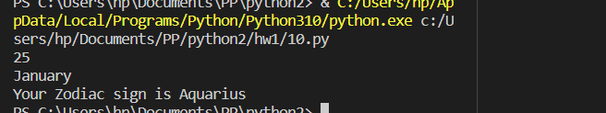

11.

#chinese zodiac sign

year = int(input())

zodiac = ["dragon", "snake", "horse", "ram", "monkey", "rooster", "dog", "pig", "rat", "ox", "tiger", "hare"]

for i in range(0, len(zodiac)):

    if (year-200)%12 == i:

        print(f"Your Chinese Zodiac Sign is {zodiac[i]}")

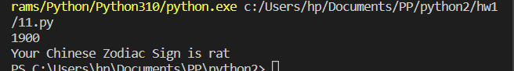

12.

variables = list(input().split())

variables.sort()

length = int(len(variables)/2)

median = float(variables[length])

print(f"The median is {median}")

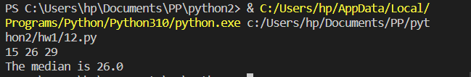

13.

#the next day

import datetime

year = int(input())

month = int(input())

day = int(input())

date = datetime.datetime(year, month, day)

the_next_day = date + datetime.timedelta(1)

print(f"The next date is {the_next_day.strftime('%d-%m-%Y')}")

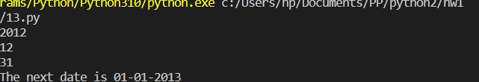

14.

#sum and average

user_input = list(input().split())

sum = 0

for i in user_input:

    if i == 0:

        break

    else:

        sum+=int(i)

average = sum/(len(user_input)-1)

print(f"The sum is equal to {sum} \nThe average is equal to {average}")

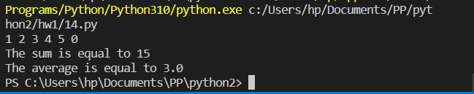

15.

#multiplication table

n = int(input())

for i in range(1, 11):

    print(f"{n} x {i} = {n*i}")

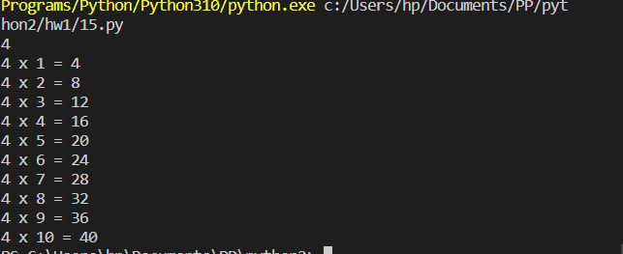

16.

#number pyramid

for i in range(1, 10):

    for j in range(1, 10):

        if j<=i:

            print(i, end = "")

    print("\n")

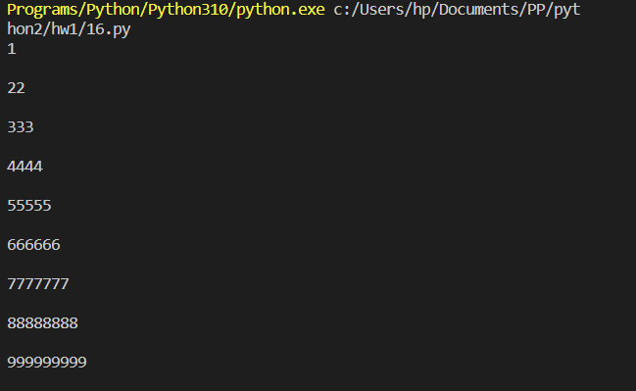

17.

datalist = [1452, 11.23, 1+2j, True, 'student', (0, -1), [5,

12], {"class":'V', "section":'A'}]

for i in datalist:

    print(f"The Type of {i} is {type(i)}")

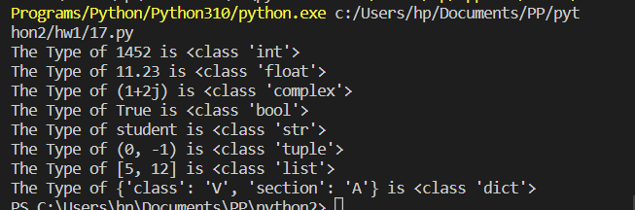

18.

#numbers [0, 6] except 3 and 6

for i in range(0, 7):

    if i == 3 or i == 6:

        continue

    else:

        print(i, end = " ")

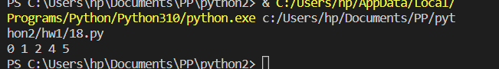

Decryptor

code = list(str(input()). split(" "))

n = int(input())

for i in range((len(code)// n)+(len(code)%n)):

    for j in range(len(code)):

        if i == ((j % ((len(code) // n)+1))):

           print(code[j], end = " " )

